EPI Registration Stage (BOLD → T1)

What is EPI Registration?
EPI registration is the process of aligning Echo Planar Imaging (EPI) data, typically the functional MRI (BOLD) image, with the subject’s structural T1-weighted anatomical image. Functional MRI scans are commonly acquired using an Echo Planar Imaging sequence, which allows rapid acquisition of brain volumes for measuring neural activity over time. However, EPI images generally have lower spatial resolution and geometric distortions compared to structural MRI images, making direct anatomical interpretation difficult.
Therefore, EPI registration is required to align the functional data with the detailed anatomical structure of the brain.
In this pipeline, this alignment is performed using the FSL tool epi_reg, which is specifically designed to register EPI images (such as functional MRI) to structural images like T1-weighted scans.

Why EPI Registration is Necessary?
Functional MRI data provide information about brain activity, but they do not clearly show anatomical brain structures. In contrast, T1-weighted images provide high-resolution anatomical detail but do not contain functional activity information.
Because of this difference, the functional image must be aligned with the structural image so that the recorded brain activity can be accurately associated with specific anatomical regions. Without this alignment, it would be difficult to determine which brain structure corresponds to a given functional signal.
Another important reason for performing EPI registration is that EPI images often contain spatial distortions caused by magnetic field inhomogeneities and acquisition limitations. Registration helps correct these distortions and improves spatial correspondence between functional and anatomical images.

Purpose of This Step in the Pipeline
The main objective of this project is to extract functional time-series signals from specific brain regions associated with Parkinson’s disease, such as the motor cortex, supplementary motor area, putamen, and substantia nigra.
To achieve this goal, the functional BOLD data must first be accurately aligned with the subject’s anatomical brain structure. This alignment ensures that the functional signals can later be associated with the correct anatomical regions when applying a brain atlas for ROI extraction.
In addition, EPI registration serves as a critical intermediate step for spatial normalization. In later stages of the pipeline, the anatomical image will be transformed into MNI standard space, and the functional image will follow the same transformation path. Therefore, accurately aligning the BOLD image with the T1 anatomical image ensures that the functional data can be reliably mapped into standard brain space.

Why Nonlinear Registration Is Not Used for BOLD → T1?*
Nonlinear registration is not used for BOLD → T1 because both images come from the same subject, so their anatomical structures already correspond closely. The differences between them are mainly due to position, orientation, and resolution, which can be corrected using affine registration.
Nonlinear registration is instead applied in the T1 → MNI step, where it is necessary to account for anatomical differences between subjects and the standard brain template. Estimating the nonlinear deformation from the high-resolution T1 image ensures more accurate normalization and allows the BOLD data to be correctly mapped to MNI space for ROI extraction.

Method Used in This Pipeline
In this project, EPI registration is performed using Boundary-Based Registration (BBR) implemented in FSL. This method improves alignment accuracy by using the intensity differences across the gray-matter and white-matter boundaries in the anatomical image.
Because the white-matter boundary provides a strong anatomical reference, BBR often produces more accurate alignment between functional and structural images compared to simpler registration methods.

Direction of registration
BOLD → T1
More precisely:
- The mean BOLD image (generated from the 4D functional data) is aligned to the T1-weighted anatomical image.
- This is done using FSL’s epi_reg tool.
Inputs used
Image | Role
mean_bold.nii.gz | Moving image (functional)
T1.nii.gz | Reference structural image
T1_brain.nii.gz | Brain-extracted structural image

Command used
epi_reg \
--epi=mean_bold.nii.gz \
--t1=T1.nii.gz \
--t1brain=T1_brain.nii.gz \
--out=func2struct
Output
func2struct.mat
This matrix represents the transformation:
BOLD space → T1 space
Mathematically:
$$x_{T1}=M x_{BOLD}$$
Where:
- $x_{BOLD}$= voxel coordinate in functional space
- $x_{T1}$= voxel coordinate in anatomical space
- $M$= affine matrix stored in func2struct.mat

Why this direction is used?
We register BOLD to T1 because:
- T1 images contain clear anatomical structures
- BOLD images are distorted and lower resolution
- Aligning functional data to anatomy allows later mapping to MNI standard space and ROI atlas regions

Visual Verification of EPI Registration*
After completing the EPI registration, the alignment between the functional BOLD image and the anatomical T1 image was checked using FSLeyes.
The following files were loaded:
- T1_brain.nii.gz (anatomical reference)
- func2struct.nii.gz (registered functional image)
The functional image was overlaid on the anatomical image to visually inspect whether the brain structures were properly aligned. This quality-control step helps confirm that the registration process correctly mapped the BOLD image into T1 anatomical space before proceeding to the next stages of the pipeline.
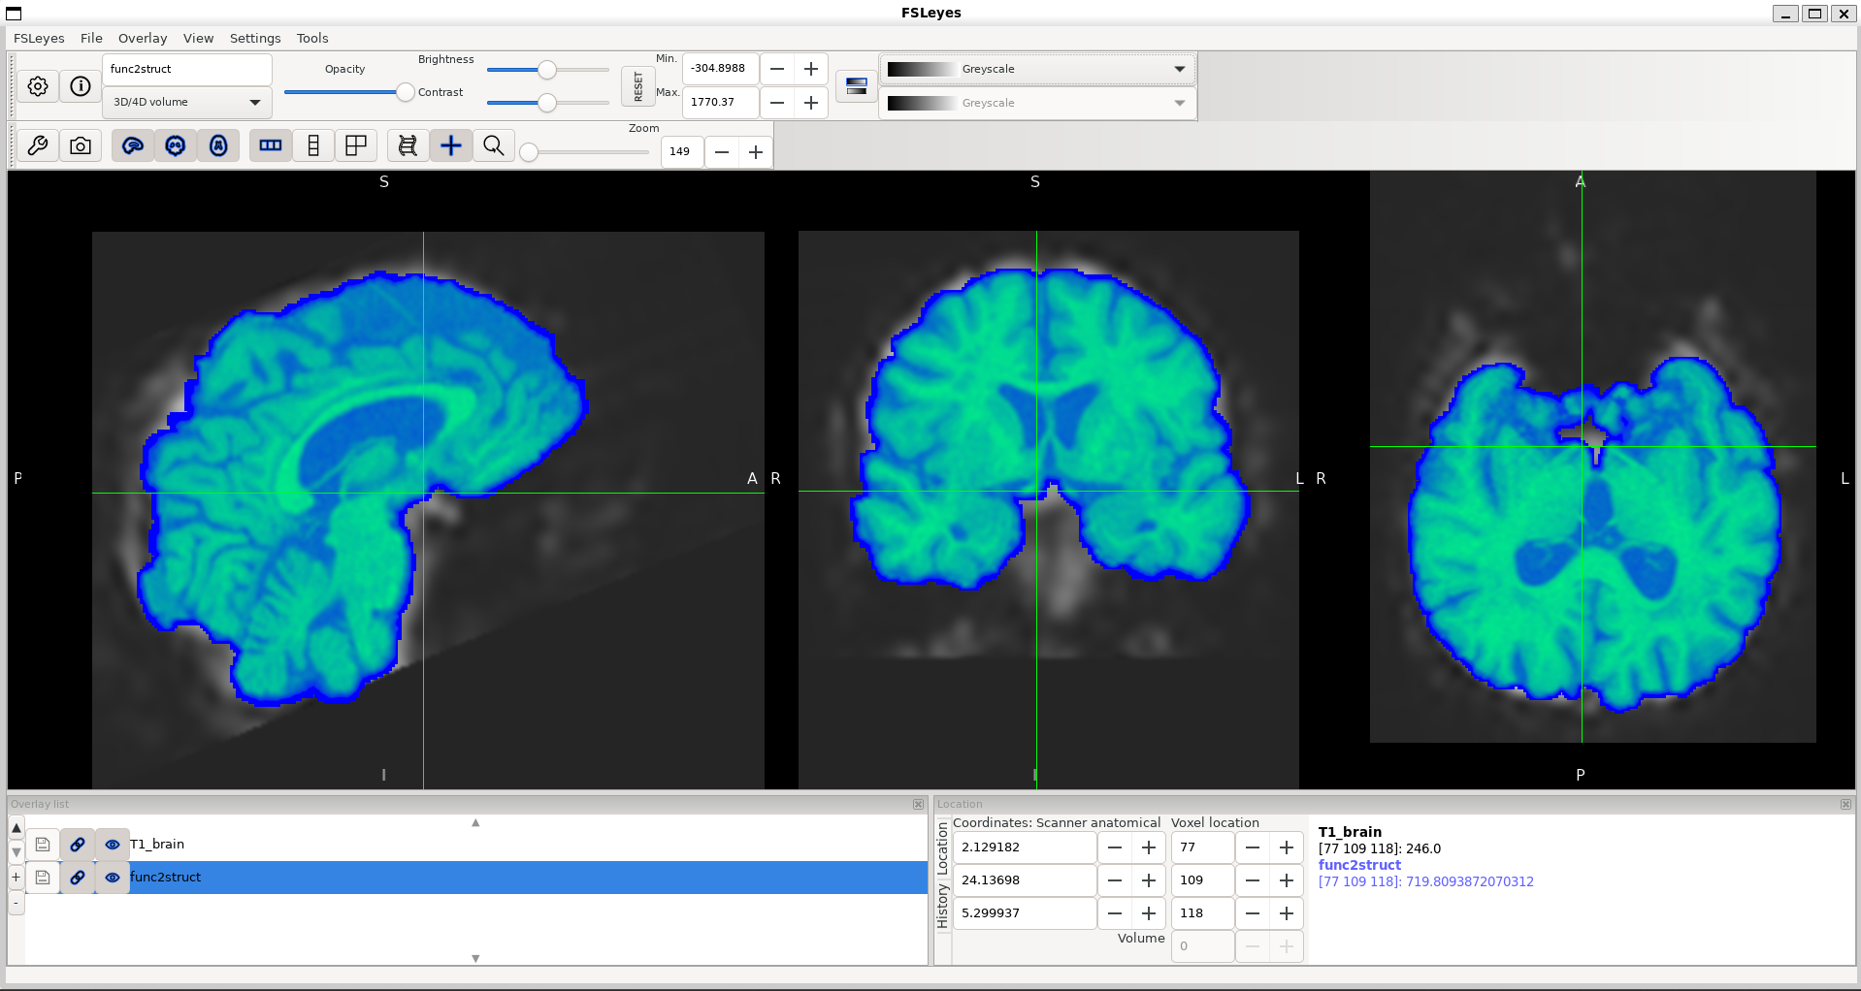
Figure: Visual verification of BOLD-to-T1 alignment after EPI registration using FSLeyes

Mathematical Interpretation of the EPI Registration Transformation
During the EPI registration stage, the tool epi_reg computes a 3D affine transformation matrix that maps coordinates from the functional EPI space to the anatomical T1 space.
The transformation matrix is stored in the file:
func2struct.mat
This matrix describes how each voxel in the functional image should be transformed so that it aligns with the anatomical image.

General Form of the Affine Transformation
A general 3D affine transformation matrix can be written as:
$$M=\left[\begin{matrix}a_{11} & a_{12} & a_{13} & t_{x} \\ a_{21} & a_{22} & a_{23} & t_{y} \\ a_{31} & a_{32} & a_{33} & t_{z} \\ 0 & 0 & 0 & 1\end{matrix}\right]$$
This matrix can be separated into two components:
$$M=\left[\begin{matrix}A & t \\ 0 & 1\end{matrix}\right]$$
Where:
- A is the $3×3$matrix describing rotation, scaling, and shear
- t is the translation vector:
$$t=\left[\begin{aligned}t_{x} \\ t_{y} \\ t_{z}\end{aligned}\right]$$
Coordinate Transformation
For a voxel coordinate in EPI space:
$$x=\left[\begin{aligned}x \\ y \\ z\end{aligned}\right]$$
The transformed coordinate in T1 space is computed as:
$$x^{'}=Ax+t$$
Expanded form:
$$x^{'}=a_{11}x+a_{12}y+a_{13}z+t_{x} \\ y^{'}=a_{21}x+a_{22}y+a_{23}z+t_{y} \\ z^{'}=a_{31}x+a_{32}y+a_{33}z+t_{z}$$
This transformation allows the coordinates of each voxel in the functional image to be mapped into the anatomical space.

- Translation Component (3 Degrees of Freedom)
The translation parameters shift the image along the spatial axes.
The translation vector is defined as:
$$t=\left[\begin{aligned}t_{x} \\ t_{y} \\ t_{z}\end{aligned}\right]$$
Interpretation of translation along the x-axis:
- $t_{x}>0$→ shift in the positive X direction
- $t_{x}<0$→ shift in the negative X direction
- $t_{x}=0$→ no shift along the X axis
Similarly, $t_{y}$and $t_{z}$control shifts along the Y and Z axes.

- Rotation Component (3 Degrees of Freedom)
Rotation is contained inside the $3×3$matrix A, but this matrix may also include scaling and shear. Therefore, the pure rotation matrix R must be extracted.
To verify that a matrix represents a valid rotation:
$$R^{T}R≈I$$
and
$$det(R)≈1$$
If these conditions hold, the matrix represents a valid rotation.
Rotation angles can be extracted using Euler angles:
$$R=R_{z}(γ)R_{y}(β)R_{x}(α)$$
Where:
- α = rotation about the X-axis
- β = rotation about the Y-axis
- γ = rotation about the Z-axis
The angles can be computed from the rotation matrix elements $r_{ij}$:
$$β=arcsin(-r_{31}) \\ α=arctan2(r_{32},r_{33}) \\ γ=arctan2(r_{21},r_{11})$$

- Scaling Component (3 Degrees of Freedom)
Scaling describes changes in the size of the coordinate system along each axis.
If the columns of matrix $A$are defined as:
$$c_{1},c_{2},c_{3}$$
The scale factors are computed as the length of each column vector:
$$s_{x}=∣∣c_{1}∣∣,s_{y}=∣∣c_{2}∣∣,s_{z}=∣∣c_{3}∣∣$$
Interpretation:
- $s_{x}=1$→ no scaling along X
- $s_{x}>1$→ expansion along X
- $0<s_{x}<1$→ compression along X
If:
$$s_{x}=s_{y}=s_{z}$$
then the transformation represents uniform scaling.
If they are different, it represents anisotropic scaling.

- Shear Component (3 Degrees of Freedom)
Shear occurs when the coordinate axes become tilted relative to each other.
To measure shear, the dot products between the normalized column vectors are computed:
$$h_{xy}=u_{1}^{T}u_{2} \\ h_{xz}=u_{1}^{T}u_{3} \\ h_{yz}=u_{2}^{T}u_{3}$$
Interpretation:
- $h_{ij}=0$→ axes are perpendicular (no shear)
- $h_{ij}≠0$→ axes are tilted (shear exists)

Role of the Affine Transformation in the Pipeline
The affine matrix produced during EPI registration transforms coordinates from the functional BOLD space into the anatomical T1 space.
This transformation is critical for the subsequent steps of the pipeline because:
- The anatomical image will later be registered to MNI standard space
- The functional image will follow the same transformation chain
- This ensures that functional signals are accurately mapped to standard brain coordinates
Accurate affine transformation therefore forms the foundation for spatial normalization and ROI-based signal extraction in the later stages of the workflow.

EPI Registration Stage Summary
- The EPI registration stage aligns the functional BOLD image with the subject’s structural T1 anatomical image.
- A mean BOLD image is used as the reference functional image to improve registration stability.
- The alignment is performed using the FSL epi_reg tool, which applies Boundary-Based Registration (BBR) for more accurate matching of anatomical boundaries.
- This process produces an affine transformation matrix (func2struct.mat) that describes how the functional image is mapped into the anatomical T1 space.
- Nonlinear registration is not used at this stage because both images belong to the same subject, and affine transformation is sufficient to correct positional and orientation differences.
- The resulting transformation ensures that functional brain activity is accurately aligned with anatomical structures.
- This alignment is essential for the subsequent stages of the pipeline, where the anatomical image is normalized to MNI standard space and the functional data follow the same transformation for ROI-based signal extraction.

